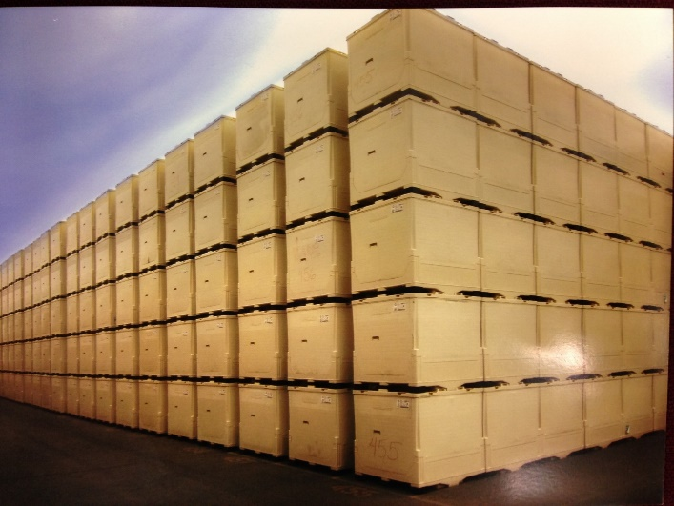

***Meet the Caliber 315 Gallon Liquid IBC***

Bottle & Cage VS. The Caliber

Opened 53’ truck = 168 containers Opened 53’ truck = 56 containers

***Stackable***

***Collapsible***

[info@tripakinc.com](mailto:info@tripakinc.com)

847.951.9025

***TRIPAK, INC.***

***Caliber Outperforms conventional IBC’s***

Up to 30% savings over bottle & cage

Minimize Contamination and Product Loss

Maximize ROI– Caliber stacks 5 High Lasts for 10+ years

Disposable Liners

Safer Employee Handling

Efficient Set up and Breakdown